**Practical 2**

**Name:** Ishaan Bose

**Reg. no.:** 2147116

**1. Describe IaaS.**

Infrastructure as a service (IaaS) is a form of cloud computing that provides virtualized computing resources over the internet. In the IaaS model, the cloud provider manages IT infrastructures such as storage, server and networking resources, and delivers them to subscriber organizations via virtual machines accessible through the internet. IaaS can have many benefits for organizations, such as potentially making workloads faster, easier, more flexible and more cost efficient.

**2. List the Compute Services available in AWS and GCP.**

**AWS Compute Services**

* Amazon Elastic Compute Cloud (Amazon EC2) — Secure and resizeable compute capacity (virtual servers) in the cloud
* Amazon EC2 Spot Instances — Run fault-tolerant workloads for up to 90% off
* Amazon EC2 Auto Scaling — Automatically add or remove compute capacity to meet changes in demand
* Amazon Lightsail — Easy-to-use cloud platform that offers you everything you need to build an application or website
* AWS Batch — Fully managed batch processing at any scale
* Amazon Elastic Container Service (Amazon ECS) — Highly secure, reliable, and scalable way to run containers
* Amazon ECS Anywhere — Run containers on customer-managed infrastructure
* Amazon Elastic Container Registry (Amazon ECR) — Easily store, manage, and deploy container images
* Amazon Elastic Kubernetes Service (Amazon EKS) — Fully managed Kubernetes service
* Amazon EKS Anywhere — Create and operate Kubernetes clusters on your own infrastructure
* AWS Fargate — Serverless compute for containers
* AWS App Runner — Build and run containerized applications on a fully managed service
* AWS Lambda — Run code without thinking about servers. Pay only for the compute time you consume.
* AWS Outposts — Run AWS infrastructure and services on premises for a truly consistent hybrid experience
* AWS Snow Family — Collect and process data in rugged or disconnected edge environments
* AWS Wavelength — Deliver ultra-low latency application for 5G devices
* VMware Cloud on AWS — Preferred service for all vSphere workloads to rapidly extend and migrate to the cloud
* AWS Local Zones — Run latency sensitive applications closer to end-users
* AWS Savings Plan — Flexible pricing model that provides savings of up to 72% on AWS compute usage
* AWS Compute Optimizer — Recommends optimal AWS compute resources for your workloads to reduce costs and improve performance
* AWS Elastic Beanstalk — Easy-to-use service for deploying and scaling web applications and services
* EC2 Image Builder — Build and maintain secure Linux or Windows Server images
* Elastic Load Balancing (ELB) — Automatically distribute incoming application traffic across multiple targets

**GCP Compute Services**

* Compute Engine — High-performance and general purpose VMs that integrate easily with other Google Cloud services and scale globally.
* Migrate to Virtual Machines — The fast, flexible, and safe way to migrate applications from on-premises, multiple data centres, or multiple clouds to Google Cloud.
* Tau VMs — Compute Engine virtual machines optimized for scale-out workloads.
* Cloud GPUs — High-performance, flexibly priced, customizable GPUs for machine learning, scientific computing, and 3D visualization.
* Spot VMs — Affordable, short-lived compute instances suitable for batch jobs and fault-tolerant workloads.
* Shielded VMs — Hardened virtual machines to help protect against remote attacks, privilege escalation, and malicious insiders and ensure your workloads are trusted and verifiable.
* Sole-tenant nodes — Dedicated hardware—physical Compute Engine servers dedicated to your workloads—for your compliance, licensing, and management needs.
* Confidential Computing — Confidential VMs are a breakthrough technology that allow customers to encrypt their most sensitive data in the cloud while it’s being processed.
* Recommender — Empower your team to automatically detect issues like overly permissive access, wrongly sized VM instances, or idle resources with easily actionable recommendations.
* Google Kubernetes Engine — A reliable, efficient, and secure way to deploy containerized applications on Kubernetes.
* Cloud Run — Develop and deploy highly scalable containerized applications on fully managed Cloud Run or on Cloud Run for Anthos.
* App Engine — Build highly scalable applications on a fully managed serverless platform using open and familiar languages and tools.

**3. Create an AWS EC2 Instance (Instance Name: Regno_EC2) and install the necessary packages to execute a program of your choice in it.**

1. Navigate to EC2 console.
2. Click on Launch Instance
3. Fill in the required details

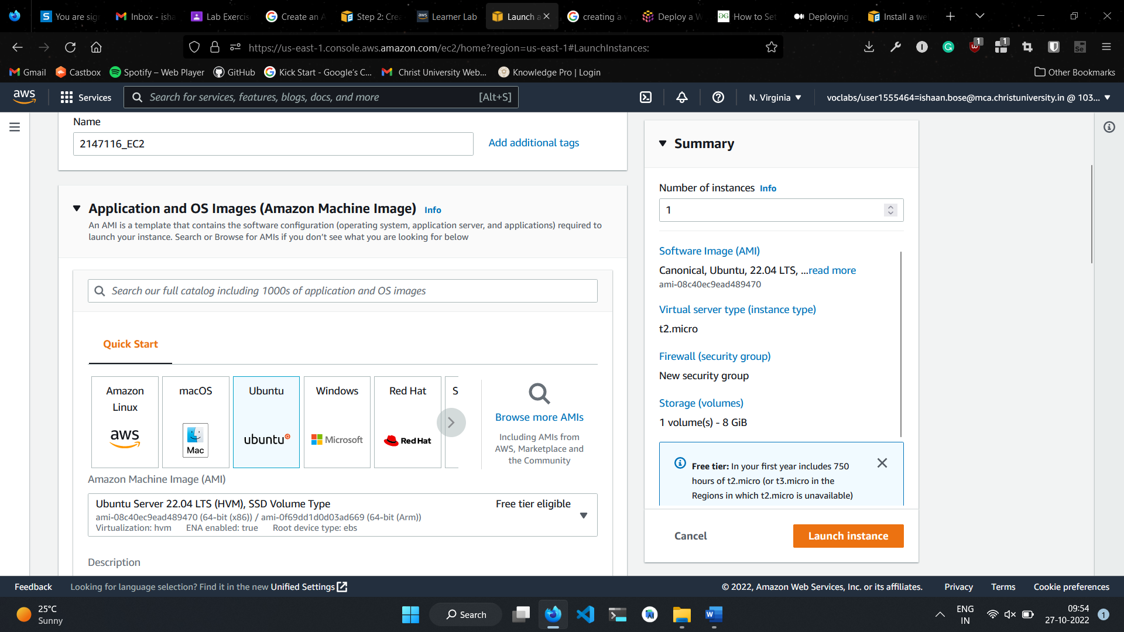

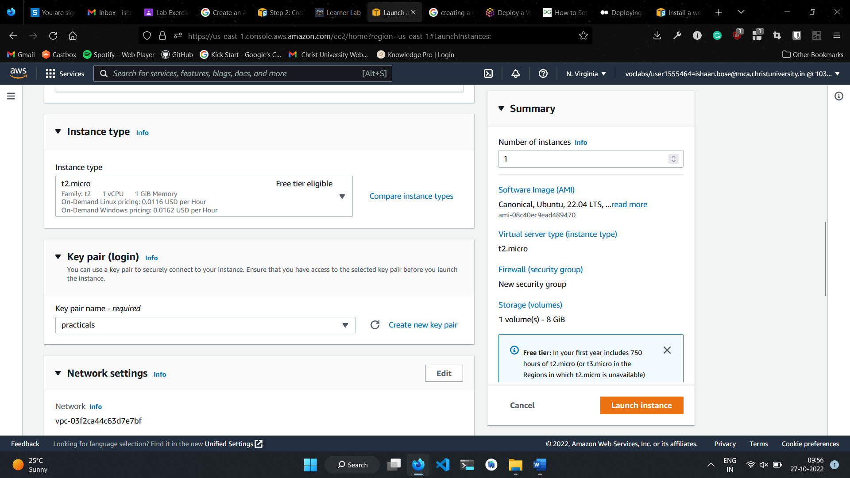

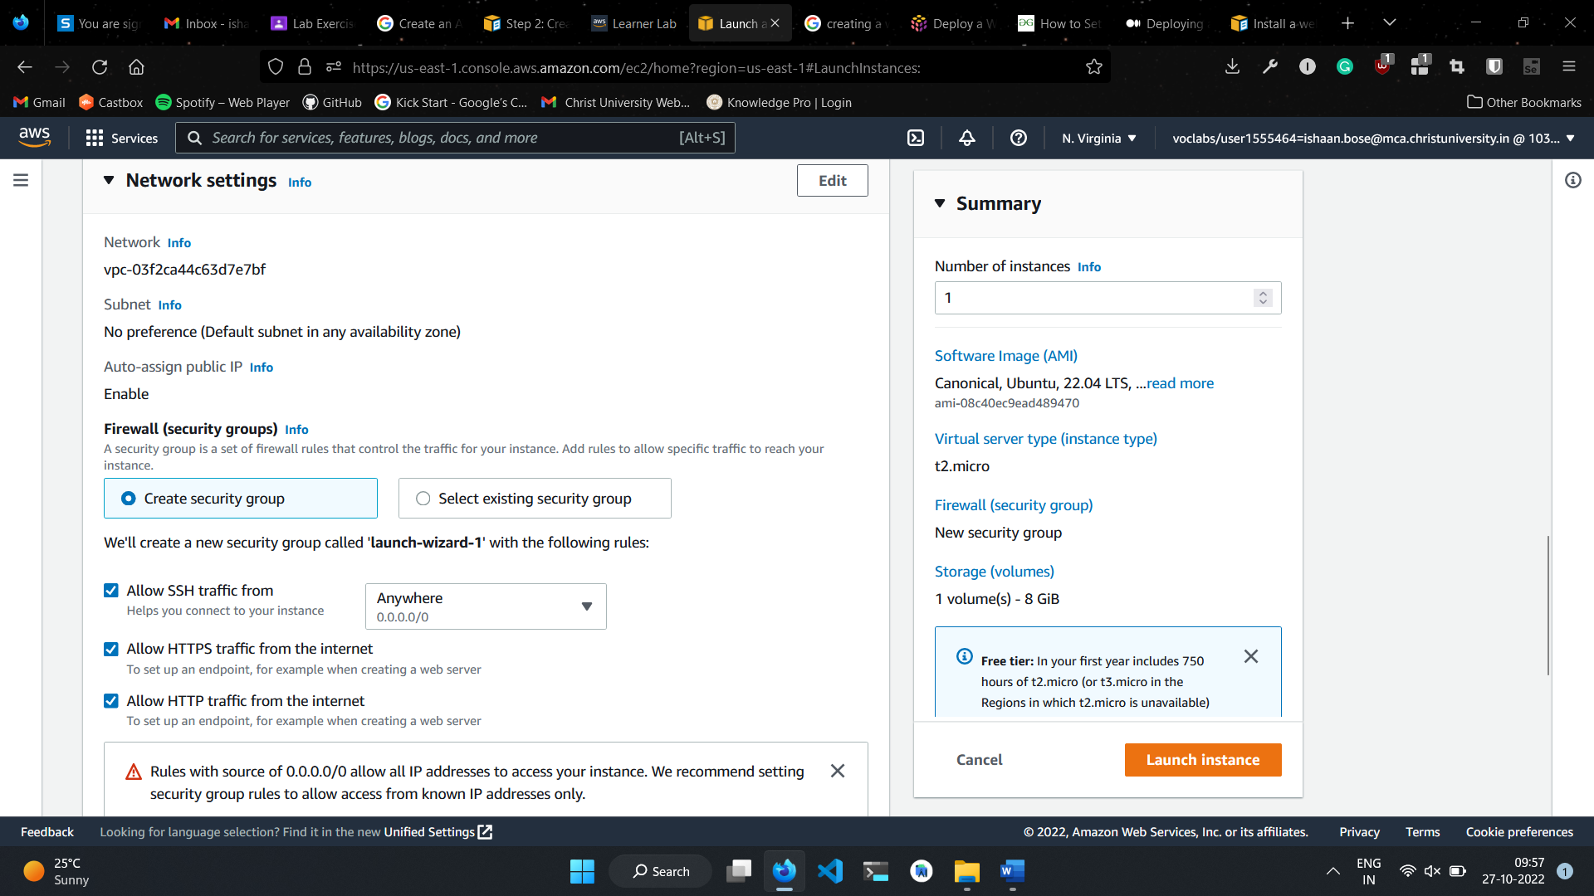

1. Finally, click on Launch Instance
2. After the instance is created, you should see a success page. Click on View all instances

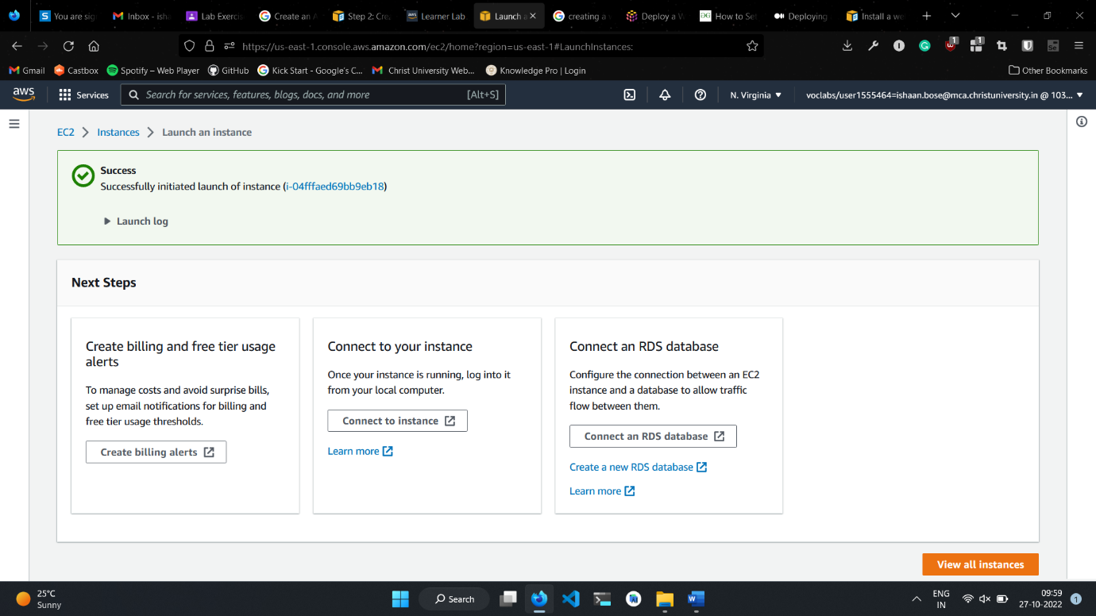

**4. Create a Webserver on that EC2 Instance and host your organizations website (Static Website)**

Continuation of previous question

1. After clicking on View all instances, you will be able to view all instances. Note down the public IPv4 address

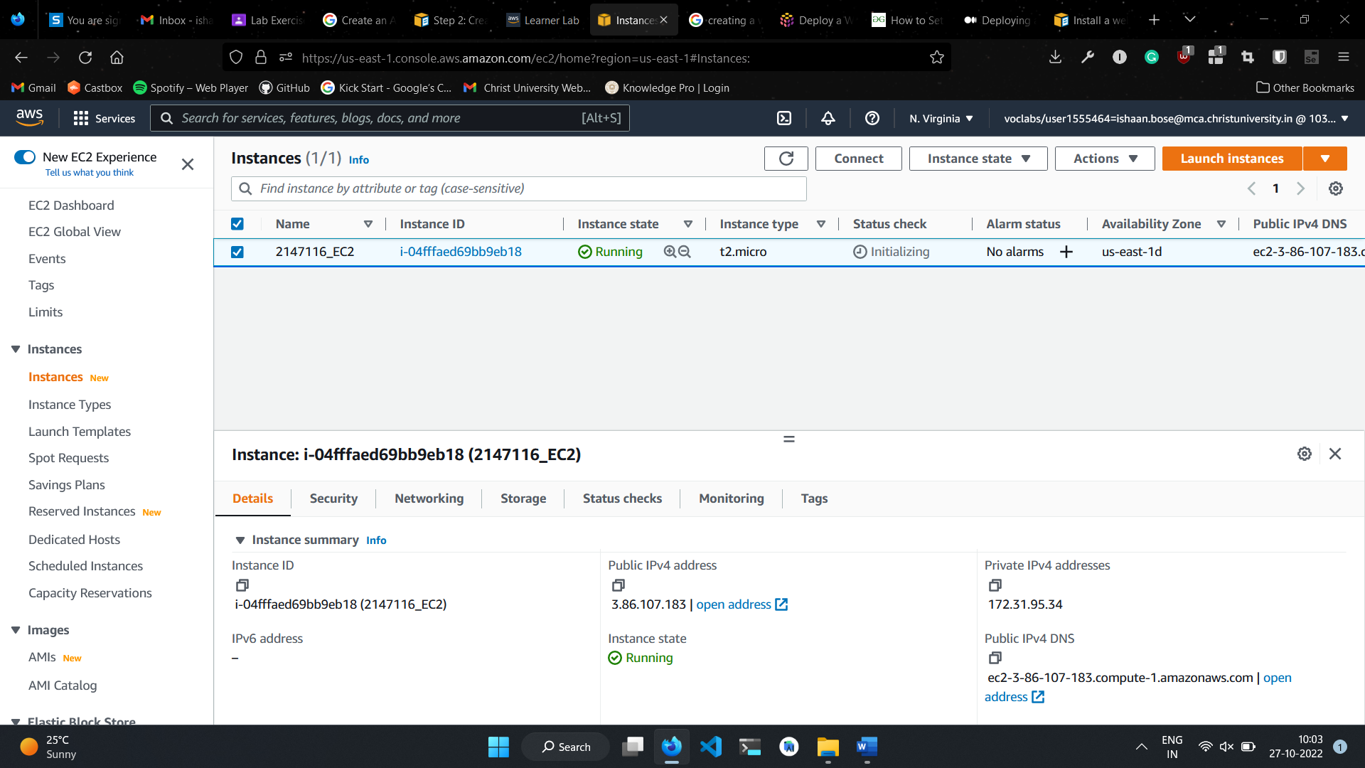

1. Navigate to where you stored the .pem file and run command: ssh -i <PEM_FILE_NAME> OPERATING_SYSTEM@SERVER_IPV4_ADDRESS

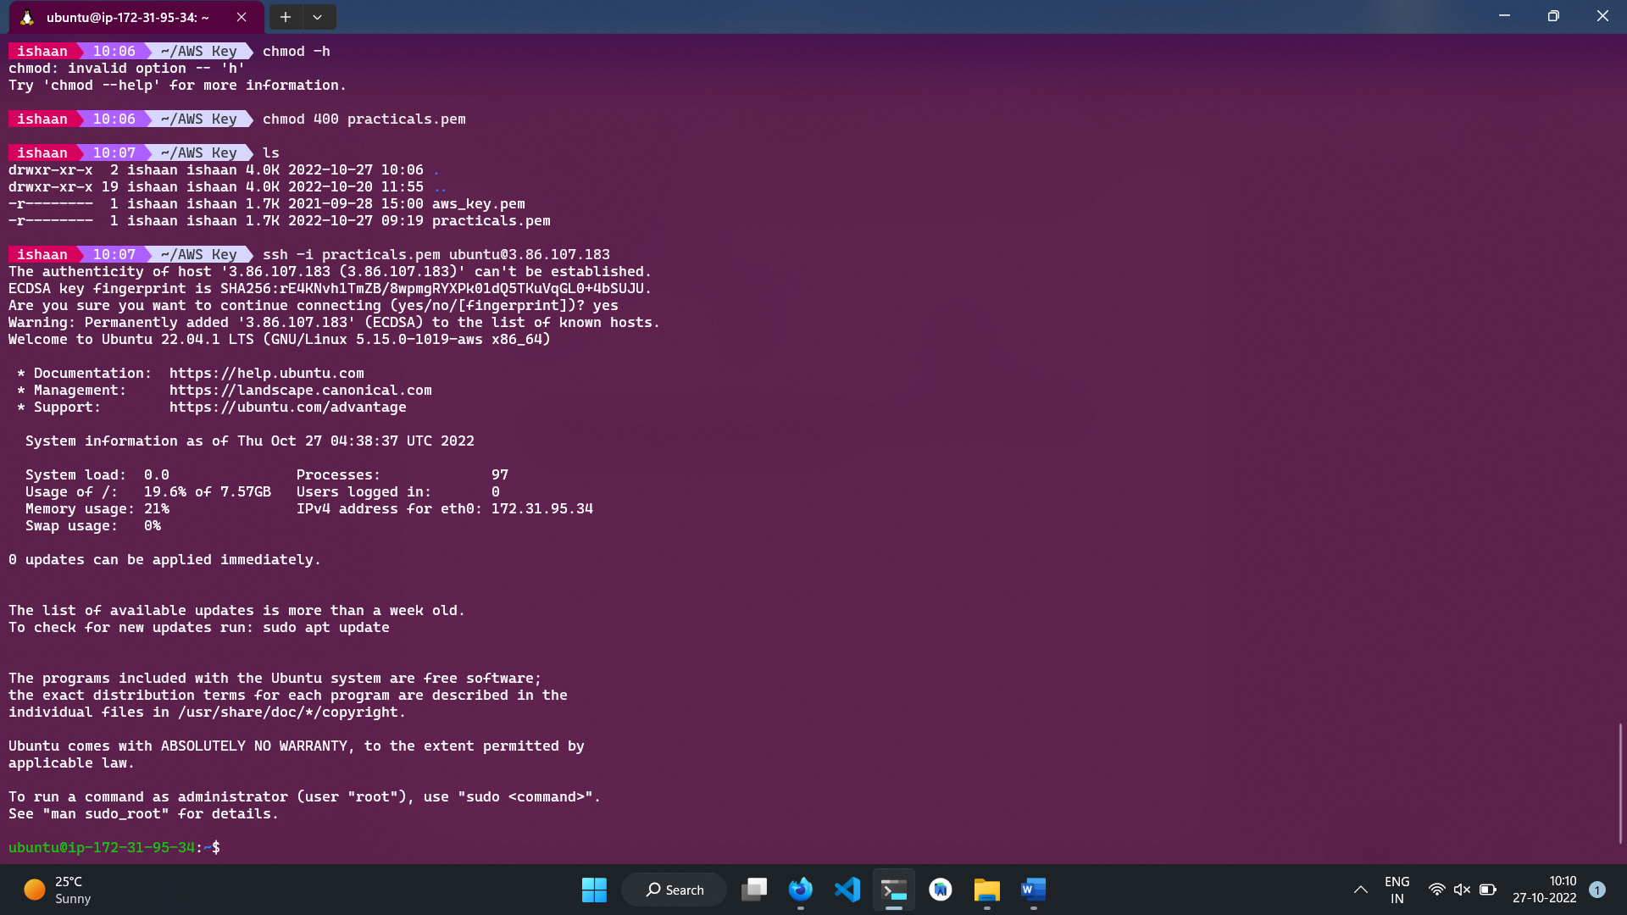

1. Run commands:
   1. curl -fsSL https://deb.nodesource.com/setup_18.x | sudo -E bash
   2. sudo apt-get install -y nodejs
2. Run command: node --version to check if node is installed
3. Next, we’ll install a package manager known as pm2 to manage our NodeJs processes so that they keep on running even when we close the current terminal session. Run command: sudo npm install -g pm2
4. Run command: pm2 --version to check if it installed
5. Create a server using Express.js. For this practical we use an already working project. To download project, run command: git clone <https://github.com/IshaanBose2147116/namma-bengaluru-front-end.git>
6. Once the project is downloaded, navigate to project folder and then to server folder and run command: npm install
7. Once all node modules are downloaded, run command: sudo iptables -t nat -A PREROUTING -p tcp --dport 80 -j REDIRECT --to-ports 5000. This will map our process running in port 5000 to port 80 (the default HTTP port)
8. Run command: npm start. This will launch our server.
9. Alternatively, we can run command: pm2 start server.js to have the running in the background.
10. Visit the website using the public IPv4 address

